# **CS 1101-01: Programming Assignment Unit 7**

Godknows Egi

Bachelor of Science in Computer Science, Uopeople

CS 1101-01 - AY2024-T3: Dictionary and tuples

Bianca Gilyot

March 21h , 2024

**Question 1**

In a program, a dictionary contains lists of students and their courses. The teacher is interested to have a dictionary that has the courses as key and the students enrolled in each course as values. Each key has three different values.

To address this requirement, write a function to invert the dictionary and implement a solution that satisfies the teacher’s need. In particular, the function will need to turn each of the list items into separate keys in the inverted dictionary. Also provide a technical explanation for the code and its output in minimum 200 words.

Sample input:

{

'Stud1: ['CS1101', 'CS2402', 'CS2001'],

'Stud2: ['CS2402’,’CS2001’,’CS1102’]

}

Inverted Output:

{

‘CS1101’: [‘Stud1’],

‘CS2402’:['Stud1’,’Stud2’],

‘CS2001’: ['Stud1’,’Stud2’]

‘CS 1102’[‘Stud2’] }

**Answer to question 1**

Here’s my solution my this assignment

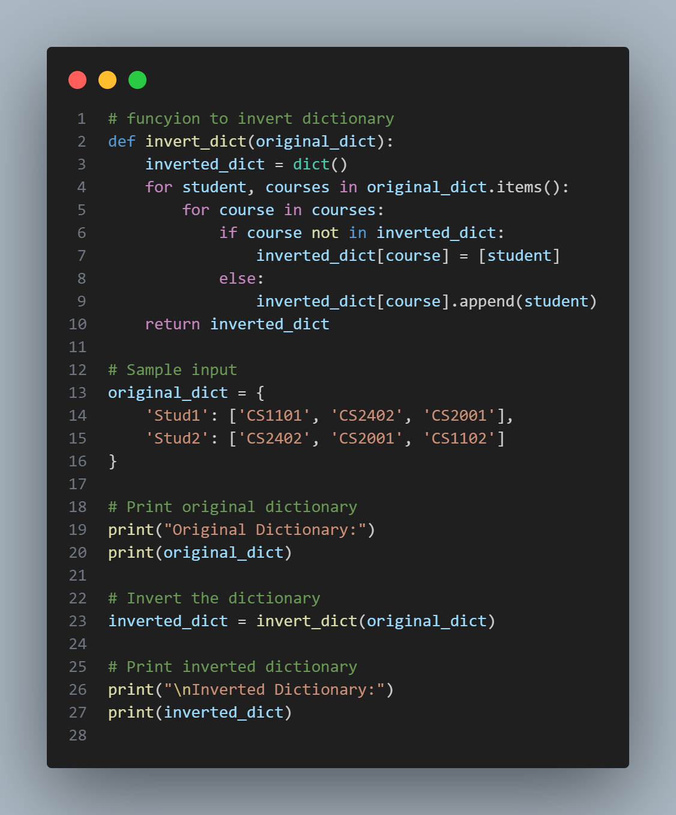

*Fig 1 (inverted dictionary)*

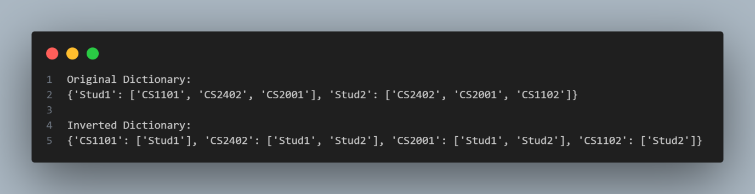

*Fig 1 output (inverted dictionary)*

Firstly declared a function **invert_dictionary** that takes the original dictionary as argument, Then I initialize an empty dictionary **inverted_dict** with the inbuilt dict functionto store the inverted dictionary.

After that i iterate through each key-value pair in the original dictionary using items() method.

I:e for every student and their courses, i iterate through the list of courses.then I added a conditional check to know if the course is not already a key in the inverted dictionary, i add it with the student as the value. If the course already exists in the inverted dictionary, I append the student to the list of values for that course. Finally, i return the inverted dictionary from the function.